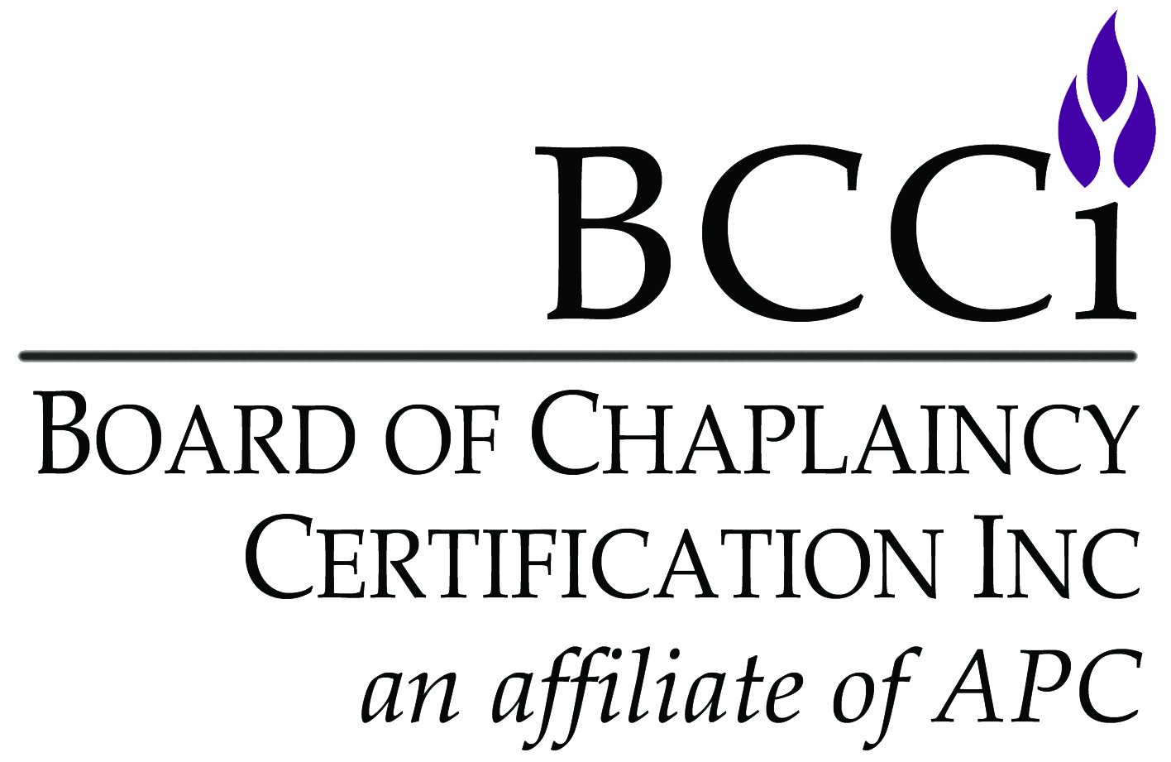
Board of Chaplaincy Certification Inc.
an affiliate of Association of Professional Chaplains
2800 West Higgins Road, Suite 295 • Hoffman Estates, IL 60169
bcci@apchaplains.org • www.apchaplains.org/bcci-site/
Phone: 847.240.1014 • Fax: 847.240.1015

CHECKLIST FOR ORGANIZATIONAL PARTNERS

IMPORTANT NOTES:
- Candidates must submit a complete file. Application is complete ONLY after all materials are received, all equivalencies
(if any) approved and all fees paid. All application materials listed below must be submitted and are not optional.
- Incomplete applications will be mailed back, and BCCI will retain a $50 administration fee for reviewing and returning incomplete materials. The candidate will have to reapply in the future.
- Submit the current application. Standards are subject to change, and you will be held to the standards in place for the year in which you apply. If your application is outdated, it will be returned to you for resubmission.
- Provide documentation of current endorsement or acceptable language in accordance with your own spiritual/faith tradition (received or reaffirmed within last 12 months). The letter must be mailed, emailed, or faxed directly to the BCCI office from your spiritual/faith group. Contact your spiritual/faith group as soon as possible to obtain your letter, as this process can take many months to complete. Spiritual/Faith groups must be recognized by the Department of Defense (Armed Forces Chaplains Board) or previously reviewed and approved by BCCI. If not, contact BCCI regarding a review of the spiritual/faith group.
- Please submit one-sided documents ONLY.
- Please no plastic sleeves, binders, staples or paperclips.
- Application form must be typed.
- Your complete application and supporting documents are only valid for one year (12 months) from the date they were received by BCCI.
Items that Must be Submitted by CANDIDATE:
Application form
Application fee (check made payable to Board of Chaplaincy Certification Inc. or provide credit card information)
Copy of certificate from an organizational partner (NAVAC certificates must be dated after 9/21/00)
Accountability for Ethical Conduct form
NAVAC applicants must submit the following additional materials:
Letter from employer verifying 2,000 hours of work experience as a chaplain
ACPE Verification Transcript documenting four units of CPE from an ACPE-accredited program
NACC applicants must submit the following additional materials:
Copy of official graduate transcripts
Letter from employer verifying 2,000 hours of work experience as a chaplain
ACPE applicants must submit the following additional materials:
Four (4) competency essays with cover pages
Three recommendation letters from:
1. Administrator
2. Board certified chaplain of APC/BCCI, ACPE, CASC, NACC, NAJC or NAVAC
3. Certified/licensed peer professional (e.g., nurse, doctor, social worker)
Item that Must be Sent Directly to BCCI Office by SPIRITUAL/FAITH GROUP:
Documentation of current endorsement or good standing in accordance with your own spiritual/faith group.
This letter must be mailed, emailed, or faxed directly to the BCCI office from your spiritual/faith group.
AFTER SUBMISSION OF THE APPLICATION
- Applications are reviewed in the BCCI office for completeness. The candidate shall be notified by the BCCI office when application materials have been reviewed and are considered complete.
- Certification will be effective after the commission has approved and the board has ratified the recommendation.
- Certificates will be awarded at the next APC annual conference (or mailed after the conference, if necessary).

APPLICATION FORM FOR ORGANIZATIONAL PARTNERS
Certification application fee: $131

NOTE: certification fee does not include APC membership. See apchaplains.org/join for information.

I am certified by: (check one):

Association for Clinical Pastoral Education (ACPE) as a supervisor or associate supervisor
Canadian Association for Spiritual Care (CASC) as a supervisor or specialist
National Association of Catholic Chaplains (NACC) as a supervisor, associate supervisor, board certified chaplain
Neshama: Association of Jewish Chaplains (NAJC) as a board certified chaplain
National Association of Veterans Affairs Chaplains (NAVAC) as a board certified chaplain
PART 1: ALL APPLICANTS
Personal Information
Salutation: Mr. Ms. Mrs. Chaplain Rev. Rabbi Father Sister Brother Imam Dr. Rev. Dr.
CH (MAJ) CH (COL) Deacon Deaconess Pastor Cantor Venerable
Spiritual/Faith Group:
Applicant’s Full Name:
Home Address:
City / State / Zip Code:
Home Phone Number: Cell Phone Number:
Home E-mail:

Demographic Information  (optional, used only for internal reporting) | Date of Birth: | Sex: | Ethnic Group:
 | / / | Male | African American | Caucasian | Hispanic
 |  | Female | Native American | Asian | Other

Please select the ONE that best describes your current work setting:
Business/Workplace | Hospital | Hospice | Palliative Care | School/University | VA Medical Facility
Corrections | Long-term Care | Military | Pediatrics | Sports | Other
Faith Community | Mental Health | Oncology | Rehabilitation Facility | Uniformed Services (police/fire/EMT)
Employer:
Position:
Work Address:
City / State / Zip Code:
Work Phone Number:
Work Fax Number:
Work E-mail:
I prefer to be contacted at: Home Work (please select only one)

Spiritual/Faith Group Endorsement Letter

1. Letter of Endorsement/Support from Spiritual/Faith Group
Provide documentation of current endorsement or acceptable language in accordance with your own spiritual/faith tradition (received or reaffirmed within last 12 months) by a recognized spiritual/faith group for work as a chaplain. The letter must be mailed, emailed, or faxed directly to the BCCI office from your spiritual/faith group.
Spiritual/Faith Group:
Endorser’s Name:
Endorsement Date:

Current Certification From Organizational Partner
Submit a copy of certificate from ACPE, CASC, NACC, NAJC or NAVAC.
Note: NAVAC certificate must be dated after September 21, 2000.
I was certified by (name of organizational partner): on (date): / /

Accountability for Ethical Conduct
Complete and return the Accountability for Ethical Conduct form on page 6.

Consent
I certify that the information in my application materials is accurate and true. I hereby authorize the BCCI office, the Commission on Certification, and certification committee to review and verify my application materials. I understand that providing false, incomplete, or misleading information may result in denial of my application. I understand that my application materials will not be shared by BCCI outside of its processes.

I agree to be invoiced for the BCCI Organizational Partner Application: Yes No


SIGNATURE: DATE

Certificate: I would like my name to appear as follows on my certificate, if recommended for certification. (You may include titles and credentials if you would like.)

NACC APPLICANTS ONLY
Education Documentation
Please submit official graduate degree(s) transcripts from institutions accredited by a member of the Council for Higher Education Accreditation (CHEA, www.chea.org).
Graduate:
Degree(s)

Hours Earned:
Any hours earned from CPE? No Yes If Yes, how many?

Work Experience
Please submit a letter from your administrator verifying 2,000 hours of work experience as a chaplain following the completion of four (4) units of CPE and apart from CPE training or residency.
Administrator’s Name:

NAVAC APPLICANTS ONLY
Work Experience
Please submit a letter from your administrator verifying 2,000 hours of work experience as a chaplain following the completion of four (4) units of CPE and apart from CPE training or residency.
Administrator’s Name:

CASC, NACC, NAJC and NAVAC applicants stop here.

Board of Chaplaincy Certification Inc.
an affiliate of Association of Professional Chaplains
2800 West Higgins Road, Suite 295 • Hoffman Estates, IL 60169
bcci@apchaplains.org • www.apchaplains.org/bcci-site/
Phone: 847.240.1014 • Fax: 847.240.1015

ACPE APPLICANTS ONLY
The following competencies must be addressed in four (4) essays, double spaced, 12-point font, one-inch margins. Essays 1 (ITP), 2 (PIC), and 4 (OL) must be no less than four and no more than six pages in length; Essay 3 (PPS) must be no less than six and no more than eight pages in length. Clearly identify and label each Essay and Competency.
Section I. Integration of Theory and Practice Competencies (Essay 1)
ITP1: Articulate an approach to spiritual care rooted in one’s spiritual tradition and integrated with a theory of spiritual care.
ITP2: Provide spiritual care that incorporates a working knowledge of an academic discipline that is not explicitly religious/spiritual (e.g., psychology, sociology, anthropology, history).
ITP3: Incorporate the spiritual and emotional dimensions of human development into one’s practice of care.
ITP4: Incorporate a working knowledge of at least one ethical theory appropriate to one’s professional context.
ITP5: Articulate a conceptual understanding of group dynamics and organizational behavior.
ITP6: Articulate how primary research and research literature inform the profession of chaplaincy and one’s spiritual care practice.

Section II: Professional Identity and Conduct Competencies (Essay 2)
PIC1: Identify one’s professional strengths and limitations in the provision of spiritual care.
PIC2: Articulate ways in which one’s feelings, values, assumptions, culture, and social location affect professional practice.
PIC3: Attend to one’s own physical, emotional, and spiritual well-being.
PIC4: Respects the physical, emotional, cultural, and spiritual boundaries of others.
PIC5: Use appropriately one’s professional authority as a chaplain.
PIC6: Advocate for the persons in one’s care.
PIC7: Function within the APC/NACC/NAJC Code of Ethics.

Section III: Professional Practice Skills Competencies (Essay 3)
PPS1: Establish, deepen, and conclude professional spiritual care relationships with sensitivity, openness, and respect.
PPS2: Provide effective spiritual support that contributes to the wellbeing of care recipients, including patients (or the relevant analogue in a non-healthcare setting), their families/friends, and staff.
PPS3: Provide spiritual care that respects diversity, relative to differences in race, culture, gender, sexual orientation, etc.
PPS4: Triage and manage crises in the practice of spiritual care.
PPS5: Provide spiritual care to persons experiencing loss and grief.
PPS6: Provide religious-spiritual resources that are appropriate to given care recipients, their spiritualities/religions, their contexts, and their goals.
PPS7: Develop, coordinate, and facilitate public/semi-public liturgy appropriate to a range of settings and needs.
PPS8: Facilitate care recipients’ own theological/spiritual/philosophical reflection.
PPS9: Facilitate group processes in the provision of spiritual care.
PPS10:Make and use spiritual assessments to inform chaplain interventions and contribute to interdisciplinary plans of care.
PPS11:Document one’s spiritual care accurately, cautiously, and usefully, and in the appropriate records.

Section IV: Organizational Leadership Competencies (Essay 4)
OL1: Promote the integration of spiritual care into the life and service of the institution in which one functions.
OL2: Establish and maintain professional and interdisciplinary relationships.
OL3: Understand and function within the chaplain’s institutional culture and systems, including utilizing business best practices appropriate to one’s role in the organization.
OL4: Advocate for and facilitate ethical decision-making in one’s workplace.
OL5: Foster a collaborative relationship with community clergy and faith group leaders.

Board of Chaplaincy Certification Inc.
an affiliate of Association of Professional Chaplains
2800 West Higgins Road • Suite 295 • Hoffman Estates, IL 60169
bcci@apchaplains.org • www.apchaplains.org/bcci-site
Phone: 847.240.1014 • Fax: 847.240.1015

ACCOUNTABILITY FOR ETHICAL CONDUCT

Please read carefully and complete Sections I or II.

Section I: I certify that (a) no complaint against me for unethical conduct has been filed, is pending, or has been settled in a civil, criminal, ecclesiastical, employment or another professional organization’s forum; and (b) I have never resigned, been terminated nor negotiated a settlement from a position for reasons related to unethical conduct.

SIGNATURE: DATE:

Section II: If the above cannot be certified, provide an account of the complaint including the forum, charges, and final outcome. Provide contact information for people involved in the process, whom you authorize to give full information to APC/BCCI representatives. Each situation will be evaluated on its own merits by the accountability review panel. Prior complaints are not an automatic bar to membership or certification. Information obtained will not be sent to the certification committee. BCCI has the right to accept or deny an applicant according to the judgment of the accountability review panel, regardless of previous complaints, other forum’s findings, or the applicant’s subsequent remedial actions. If denied, the applicant may resubmit an application at a later time. Decisions are final and binding. (Attaching additional pages is encouraged.)

Please read carefully and sign Section III.

Section III: I understand that as a condition of certification by BCCI and membership in the Association of Professional Chaplains, I will provide to the association timely notice of any complaint of unethical conduct filed against me (APC Code of Ethics, Standard 130.34). I agree to provide to the APC Commission on Professional Ethics in a timely fashion the information it requests regarding the investigation, adjudication, dismissal or settlement of such complaint. Failure to report or provide accurate, full and truthful information may be grounds for discipline including removal of membership in the Association of Professional Chaplains and removal of BCCI certification.

SIGNATURE: DATE:

PRINTED NAME:

